Task 1: Create Resource Group with Tags
What to do:
Create a resource group in the East US region with the following tags:
Tag | Value
Department | IT
Environment | Production
CostCenter | 1001
Owner | Your full name
Acceptance Criteria:
- Resource group exists in East US
- All 4 tags are visible in the resource group overview

Create Resource Groups in Azure portal
- Sign in to the Azure portal.
- Select Resource groups.
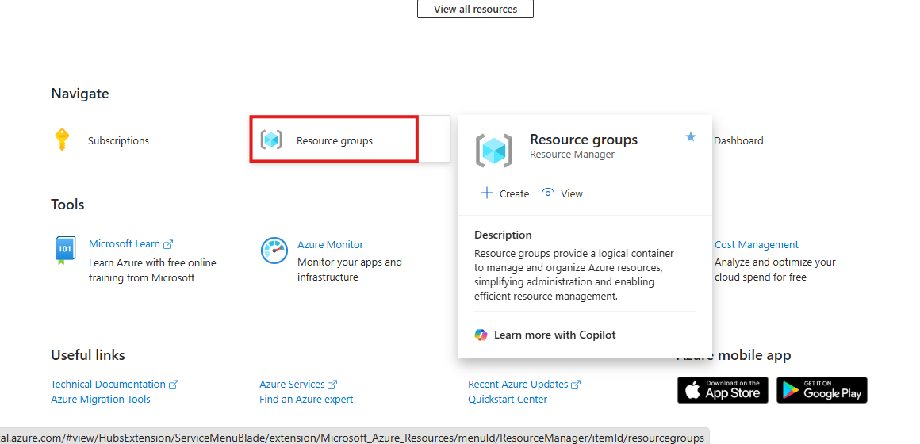

- Select Create.
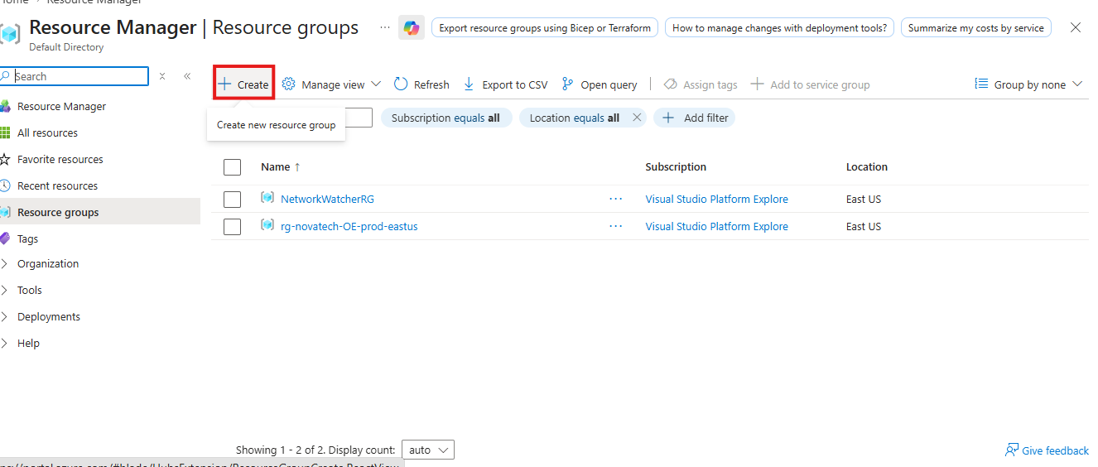

- Enter the following values:
- Subscription: Select your Azure subscription.
- Resource group: Give the resource group a name.
- Region: Select an Azure location East US
- Click Next
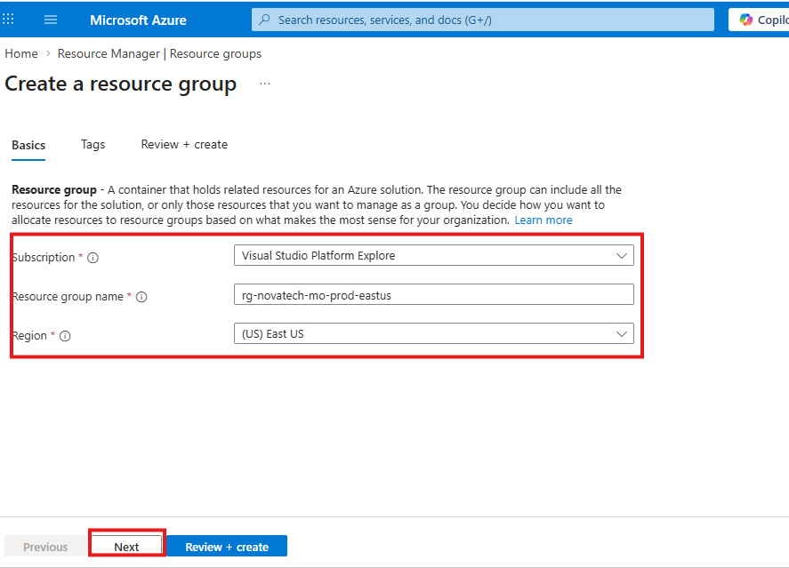

- Enter the following Tag values:
- Department: IT
- Environment: Production
- CostCenter: 1001
- Owner name: Your name
Click Review + Create: To review the settings and Click Create
